Medly Fitbit Integration

# Proposed Technical Requirements/Background

Fitbit API documentation available at: <https://dev.fitbit.com/docs/basics/>

New Fitbit Data retrieved as JSON objects

Can read/write data only through web API (not directly through device)

Must redirect to original Fitbit Authentication Page to get authentication code & token

App must be registered on Fitbit website (<https://dev.fitbit.com/apps>)

Intraday time series data only available to “personal” applications (exceptions granted on case-by-case basis through <https://dev.fitbit.com/docs/help/>)

API is rate limited (150 API requests/hr/user + 150/hr for application)

Subscription Service Available: <https://dev.fitbit.com/docs/subscriptions/#overview>

Proposed/Anticipated Data Flow Diagrams for additional data: [Lucid Chart Medly Fitbit Integration](https://www.lucidchart.com/documents/edit/0eb40f50-324a-4e98-8100-b408b00338f7)

* Medly - Fitbit Authentication/Integration
* Medly - Fitbit Patient Access
* Medly - Fitbit Clinician Access
* Medly - Fitbit Quality Improvement/Research Access

ǂ indicates intraday values not available (only daily or as measured manually)

P indiciates visible patient

C indicates visible to clinician

Q indicates visible to QI/researcher

? indicates point requires feedback from appropriate stakeholder

## Current Data:

**Weight**

* manual or weight scale ǂPCQ

**Blood Pressure**

* manual or BP cuff ǂPCQ

**Pulse**

* manual or BP cuff ǂPCQ

**Symptoms**

* manual ǂPCQ

**Test (Lab) Results**

* in progress ǂPCQ

## New Fitbit Data:

**Heart Rate**

Heart PCQ

**Estimated Oxygen Uptake**

* I will have to calculate this: PCQ
  + Uth-Sorensen-Overgaard-Pedersen Estimation: ${VO}_{2 max}≈15.3*\frac{{HR}_{max}}{{HR}_{rest}}$
  + Cooper Test: ${VO}_{2 max}≈\frac{d_{in meters in 12 minutes}-504.29}{44.73}=\left(35.97 * d_{in miles in 12 minutes}\right)-11.29$
  + Rockport fitness walking test: ${VO}_{2 max}≈132.853 - 0.0769*{BW}_{in lbs}-0.3877*age -3.2649*t_{in minutes to travel a mile}-0.1564*{HR}_{at end of mile}+\left\{male ? 6.3150 :0\right\}$
  + Firstbeat method: patented

**Step Count**

activities/steps PCQ?

activities/tracker/steps PCQ

**Distance Travelled**

activities/distance CQ?

activities/tracker/distance CQ

**Elevation/Flights of Stairs Travelled**

activities/floors CQ?  
activities/elevation CQ?

activities/tracker/floors CQ  
activities/tracker/elevation CQ

**Time Spent Active**

activities/minutesLightlyActive ǂCQ?  
activities/minutesFairlyActive ǂCQ?  
activities/minutesVeryActive ǂCQ?

activities/tracker/minutesLightlyActive ǂCQ?  
activities/tracker/minutesFairlyActive ǂCQ?  
activities/tracker/minutesVeryActive ǂCQ?

**Time Spent Sedentary**

activities/minutesSedentary ǂCQ?

activities/tracker/minutesSedentary ǂCQ?

**Other?**

activities/activityCalories ǂQ

activities/calories Q  
activities/caloriesBMR ǂQ

activities/tracker/activityCalories ǂQ?

activities/tracker/calories Q?  
activities/tracker/caloriesBMR ǂQ?

devices/* Q

body/* CQ?

profile/* CQ?

# Proposed Visual Requirements/Background

## Patient Views (Low Fidelity Examples)

Ink Drawings
Ink Drawings
Ink Drawings
Ink Drawings
Ink Drawings
Ink Drawings
Ink Drawings
Ink Drawings
Ink Drawings
Ink Drawings
Ink Drawings
Ink Drawings
Ink Drawings
Ink Drawings
Ink Drawings
Ink Drawings
Ink Drawings
Ink Drawings
Ink Drawings
Ink Drawings
Ink Drawings
Ink Drawings
￼￼￼￼￼
￼
￼
￼
￼￼￼
￼￼￼￼￼
￼￼￼￼￼￼￼￼￼￼￼
￼￼￼￼￼￼￼￼
￼￼￼
￼￼￼￼￼
￼￼￼
￼
￼
￼￼￼￼
￼￼￼
￼￼￼￼￼￼￼￼￼￼￼
￼￼￼￼￼
￼￼￼
￼￼￼￼￼
￼￼￼￼￼
￼￼￼
￼
￼
￼
￼
￼
￼
￼
￼￼￼
￼
￼
￼￼￼￼￼￼￼￼￼
￼￼￼
￼
￼￼￼￼￼￼
￼￼￼￼￼￼￼￼￼￼￼￼￼￼￼￼
￼
￼
￼￼￼￼￼￼￼￼￼￼￼￼￼￼￼￼￼￼￼￼￼￼￼
￼
￼￼￼
￼￼
￼￼￼￼￼￼￼￼
￼￼￼￼￼￼￼￼￼￼￼
￼
￼
￼
￼￼￼
￼
￼￼￼
￼￼￼￼
￼
￼
￼￼￼
￼
￼￼￼
￼￼￼￼￼￼
￼
￼￼￼￼￼￼￼￼￼
￼
￼
Ink Drawings


Shall at minimum:

Provide feedback to patient that fitness tracker is connected.

Allow for connection/authentication of fitness tracker.

Provide feedback to patient that the fitness tracker is working and collecting data.

Provide method to de-authenticate fitness tracker?

## Clinician Views (Low Fidelity Examples)

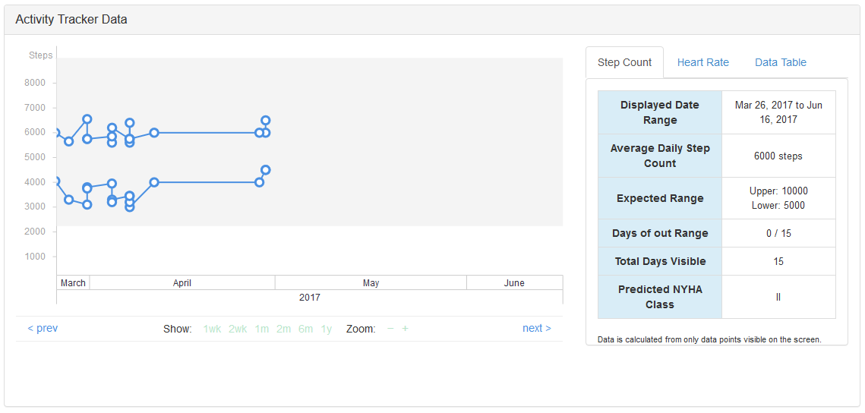

Shall at minimum:

Provide feedback to clinician that fitness tracker is working

Provide means by which clinician can view heart rate data

Provide means by which clinician can view activity data

Clinician needs to be able to easily (see simultaneously) relate heart rate and contextual ‘explainers’ or heart rate (activity data, medications, etc.)

Alerts (TBD – but likely to include):

Higher than expected BPM

Sustained higher than expected BPM

Sustained lower than expected activity levels (step count)

Sustained lower than expected activity levels (distance)

Fitbit de-authorized/disconnected

## QI/Research Views

Shall at minimum:

Be able to download/access anonymized bulk data from application server to do independent processing